LAB EXPERIMENTS
(Sequence Diagrams)
1. Library Management System
Aim:
To represent the sequence of interactions between Student, Librarian, and Library System for searching, issuing, and returning books.
Algorithm:
- Start
- Student sends search request.
- Library system checks book availability.
- Librarian issues the book if available.
- Student returns the book.
- System updates the database.
- Stop.
Input:
Student request, Book ID, Issue/Return request.
Output:
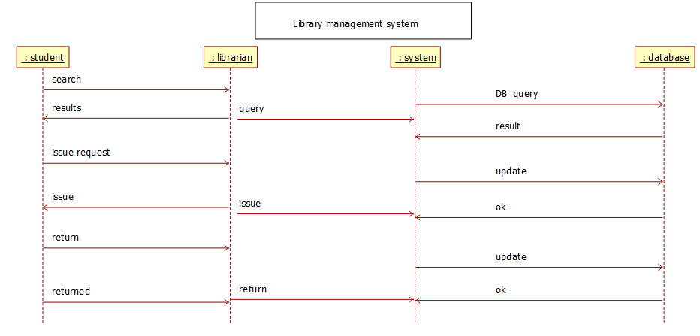
Result:
The Sequence Diagram shows the order of messages exchanged between Student, Librarian, and Library System.
2. Online Shopping / E-Commerce System (Sequence Diagram)
Aim:
To illustrate the sequence of interactions between User, Shopping System, and Vendor for purchasing products.
Algorithm:
- Start
- User searches for a product.
- System displays product details.
- User adds product to cart.
- User proceeds to checkout.
- Payment is processed.
- Order confirmation is sent.
- Stop.
Input:
User login details, Product selection, Payment details.
Output:
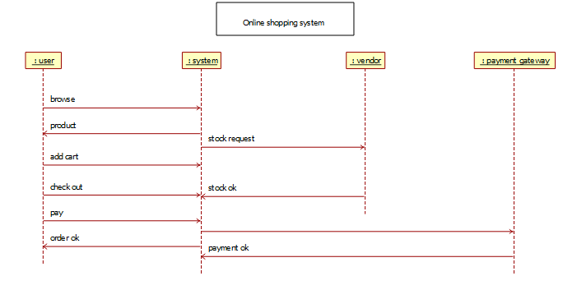
Result:
The Sequence Diagram shows the flow of messages between User, System, and Vendor during online shopping.
3. Hospital Management System (Sequence Diagram)
Aim:
To represent the sequence of interactions between Patient, Receptionist, Doctor, and Hospital System.
Algorithm:
- Start
- Patient registers at reception.
- Receptionist schedules appointment.
- Doctor checks patient details.
- Doctor provides diagnosis and treatment.
- System stores patient record.
- Stop.
Input:
Patient details, Appointment request, Medical data.
Output:
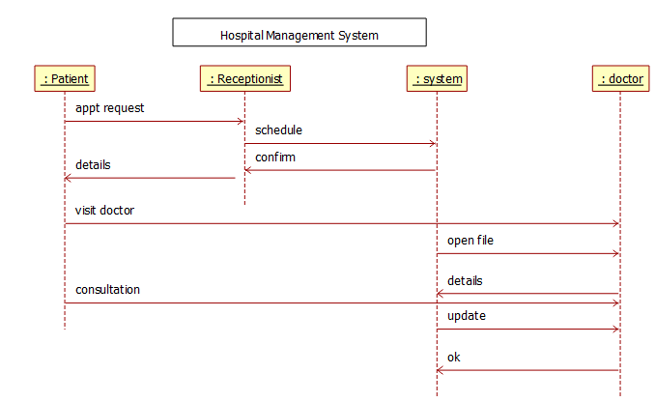
Result:
The Sequence Diagram illustrates the communication flow among Patient, Receptionist, Doctor, and System.
4. Railway Reservation System (Sequence Diagram)
Aim:
To illustrate the sequence of interactions for ticket booking, cancellation, and checking ticket status.
Algorithm:
- Start
- Passenger searches for train availability.
- System displays train details.
- Passenger books ticket.
- System confirms reservation.
- Passenger may cancel ticket if needed.
- Ticket checker verifies ticket.
- Stop.
Input:
Passenger details, Train number, Travel date.
Output:
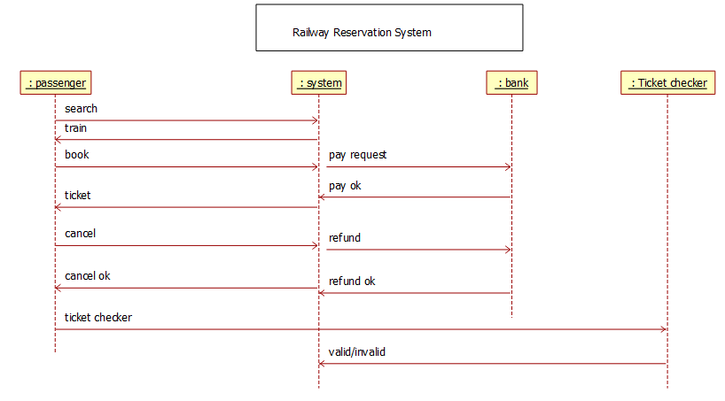
Result:
The Sequence Diagram shows the order of communication between Passenger, Reservation System, and Ticket Checker.
5. Student Information System (SIS)
Aim:
To model interactions between Student, Teacher, Administrator, and SIS.
Algorithm:
- Start
- Student logs into system.
- Student views course details.
- Teacher enters student grades.
- Administrator updates records.
- System stores information in database.
- Stop.
Input:
Student login details, Course data, Marks information.
Output:
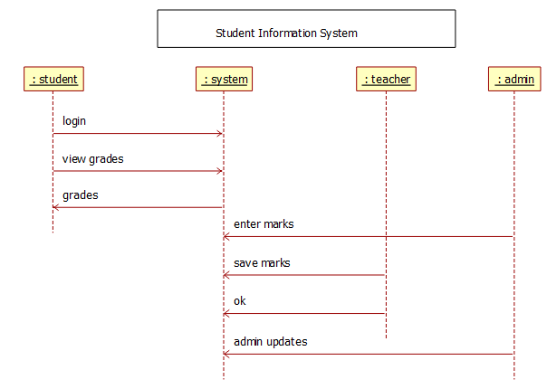

Result:
The Sequence Diagram shows the sequence of interactions among Student, Teacher, Administrator, and SIS.
6. University Management System
Aim:
To represent the sequence of interactions for course registration, grade entry, and transcript generation.
Algorithm:
- Start
- Student selects course for registration.
- System verifies course availability.
- Faculty enters grades.
- System calculates results.
- Transcript is generated.
- Stop.
Input:
Student details, Course selection, Grade details.
Output:
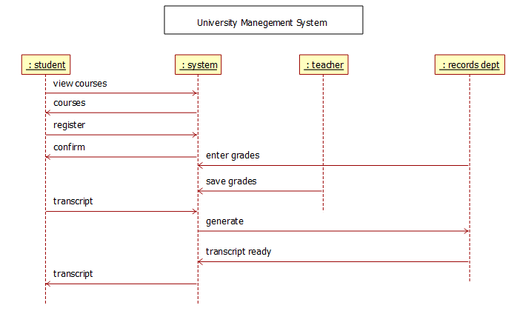
Result:
The Sequence Diagram shows communication between Student, Faculty, and University System.
7. Employee Payroll System
Aim:
To illustrate interactions between Employee, HR/Admin, and Payroll System for salary processing.
Algorithm:
- Start
- HR enters employee information.
- System calculates salary and deductions.
- Payroll is processed.
- Salary slip is generated.
- Employee receives payslip.
- Stop.
Input:
Employee details, Attendance data, Salary structure.
Output:
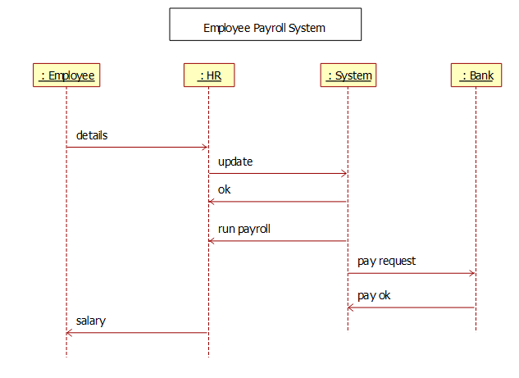
Result:
The Sequence Diagram represents the message flow between Employee, HR, and Payroll System.

